Name: | ___________________________________________________ |  | Date: ___________
 | Year 9 Maths  Investigation 2, 2012  Topic – Space and Measurement  Take - Home Component |  | 52  = %
Weighting | 3% of the year. | BONUS MARKS (look at the whole assessment):  q Units: appropriate (+1). If inconsistent (+1/2 only)
Equipment: | Calculator
Important Information:
This part of the assignment will be completed at home over a period of up to one week. This part of the assignment is worth 3% of the marks for the year.

AIM: In this assessment, you will be investigating the perimeter of figures made from 1cm squares..

Marks Summary

Task | Marks available | Marks awarded
1 | - | -
2 | 3
3 | 10
4 | 12
5 | 16
6 | 8
7 | 2
Bonus | 1
Part 1 | 52

Task 1 | [No marks]
a) | This is a one centimetre (1 cm) square. That means it has sides of 1cm.  The perimeter is the distance around the outline of the shape and is therefore 4 cm. | 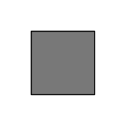
b) | Here are two squares that meet at a corner.  The perimeter of this shape is 8 cm. | 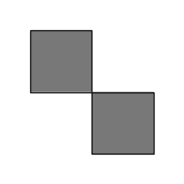
c) | Here are two squares that share a side, with the side they share shown in bold.  The distance around the outside of the shape (its perimeter) is 6 cm.  You will notice that sharing sides reduces the perimeter. | 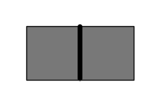
Task 2 [3 Marks]
These diagrams show examples of three connected 1cm squares with various numbers of shared sides. Calculate the perimeter of each.
 | a) No shared sides  Perimeter = ________________ [1] | 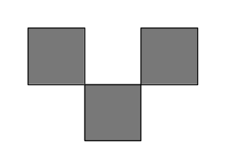
 | b) One shared side  Perimeter = ________________ [1] | 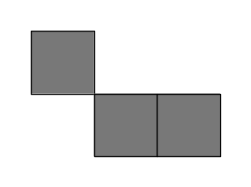
 | c) Two shared sides  Perimeter = ________________ [1] | 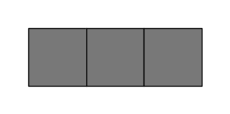

Task 3 [10 Marks]
Draw diagrams to show examples of four connected 1cm squares with various numbers of shared sides and calculate the perimeter of each.
 | a) No shared sides  Perimeter = ________________ [1] | [1]
 | b) One shared side  Perimeter = ________________ [1] | [1]
 | c) Two shared sides  Perimeter = ________________ [1] | [1]
 | d) Three shared sides  Perimeter = ________________ [1] | [1]
 | e) Four shared sides  Perimeter = ________________ [1] | [1]

Task 4 [12 Marks]
Draw diagrams to show examples of five connected 1cm squares with various numbers of shared sides and calculate the perimeter of each.
 | a) No shared sides  Perimeter = ________________ [1] | [1]
 | b) One shared side  Perimeter = ________________ [1] | [1]
 | c) Two shared sides  Perimeter = ________________ [1] | [1]
 | d) Three shared sides  Perimeter = ________________ [1] | [1]
 | e) Four shared sides  Perimeter = ________________ [1] | [1]
 | f) Five shared sides  Perimeter = ________________ [1] | [1]

Task 5 [16 Marks]
Draw diagrams to show examples of six connected 1cm squares with various numbers of shared sides and calculate the perimeter of each.
 | a) No shared sides  Perimeter = ________________ [1] | [1]
 | b) One shared side  Perimeter = ________________ [1] | [1]
 | b) Two shared sides  Perimeter = ________________ [1] | [1]
 | c) Three shared sides  Perimeter = ________________ [1] | [1]
 | d) Four shared sides  Perimeter = ________________ [1] | [1]
 | e) Five shared sides  Perimeter = ________________ [1] | [1]
 | f) Six shared sides  Perimeter = ________________ [1] | [1]
 | g) Seven shared sides  Perimeter = ________________ [1] | [1]

Task 6:[8 Marks: 2, 2, 2,2]
Summarise your findings by putting the results from the above tasks into the table below:
Number of squares | Maximum perimeter (cm) | Minimum perimeter (cm)
1 (Task 1) | 4 | 4
2 (Task 1) | 8 | 6
3 (Task 2)
4 (Task 3)
5 (Task 4)
6 (Task 5)

Task 7: | [2 Marks]  Do you notice any connection between the number of squares and  - the maximum perimeter?  - the minimum perimeter?  If so make notes here:

